Dash Application

Dash application syntax is much simpler to understand and implement, to one who is already familiar with React.js. Dash framework is an open-source and used for creating analytical (data science and ML) web applications (dashboards used by business users) that can be written in Python, R, and Julia. We tried to do visualization in matplotlib and bokeh, but both were slightly difficult to code in.
To run the dash application, we need to execute the dash app index.py file from terminal or ide. Dash will run on http://127.0.0.1:8050/,8050 is default port number but can be change as per need by using app.run_server(port=’8888’). Dash apps are composed of two parts. The first part is the “layout” of the app which basically describes how the application looks like. The second part describes the interactivity of the application.
Dash application consists of two parts – side-bar in the main layout of the dashboard to navigate between multiple pages of the application and container where the specific page will be loaded. User will choose between chart type want to see then all files corresponding to that specific chart will be executed, and shown into the container of application. Interactive and dynamic graphs are been created on this dashboard. Data is being pulled from MongoDB and on run time graphs are been plotted into the dashboard of the dash application. So even if new data been stored in the database, graphs can be updated onto the dash app. New feature of dash called pattern matching is been used too.
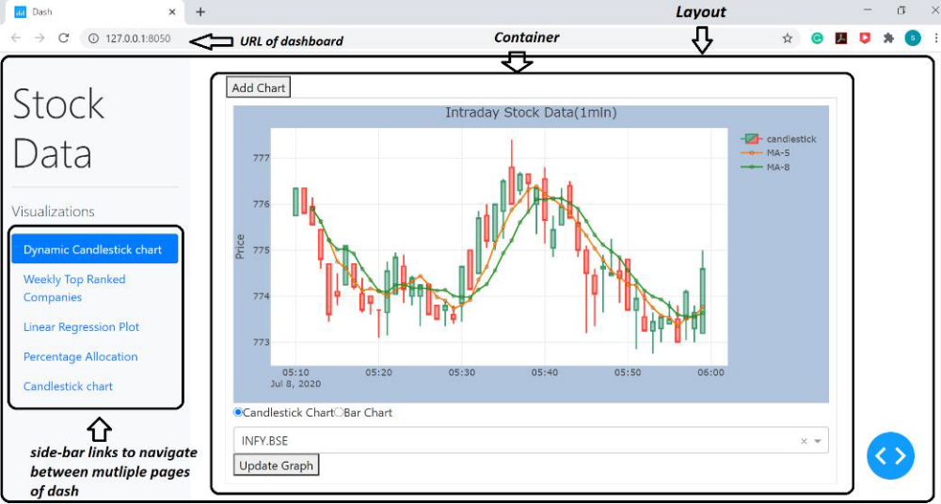

Dash Application Layout

Packages will be needed to create dash application are -
dash, dash_core_components, dash_html_components, plotly.express or plotly.graph_objs, dash.dependencies (from dash.dependencies import INPUT,OUTPUT,MATCH), numpy, pandas , dash_bootstrap_component.
dbc.Nav and dbc.NavLink function are been used inside side-bar for creating navigation link. A render_page_content() callback function will take pathname, which will be passed from dbc.Nav. The function will try match the pathname to its specific page of dash application and then render content of that page into the layout along with sidebar.
app.layout = html.Div([dcc.Location(id="url"), sidebar, content])
Dash application will be load and start running at port 8050. We have specified dynamicCandleStickChart.py as page-1 as home/index page in the application, so data required to create graphs onto that page will be pulled from mongoDB , some data processing will done (removing duplicates and dropping ‘_id’ column, sorting of data according to date) to feed it into the interactive/dynamic graphs. In last step data will be set into the ploty graph plots and then graphs along with current data will be displayed in dashboard. Same process will happen, when user will select any other navlink from side-nav bar. If application does not find link page, then it will display message – ‘404: Not found’ into the section where pages are been load.

Visualizations
Intraday Candlesticks charts with moving average and volume of stocks traded chart:
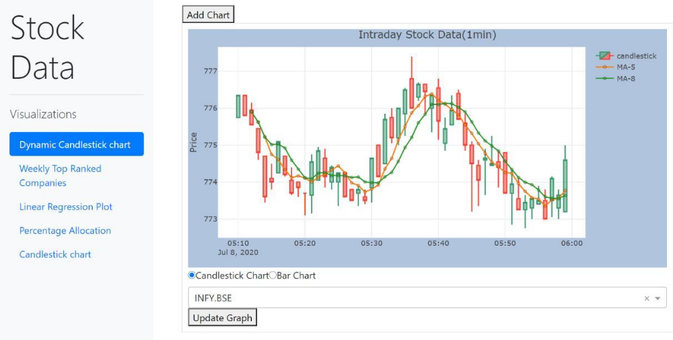

Intraday Stock Data for INFY.BSE (1min): Candlestick chart

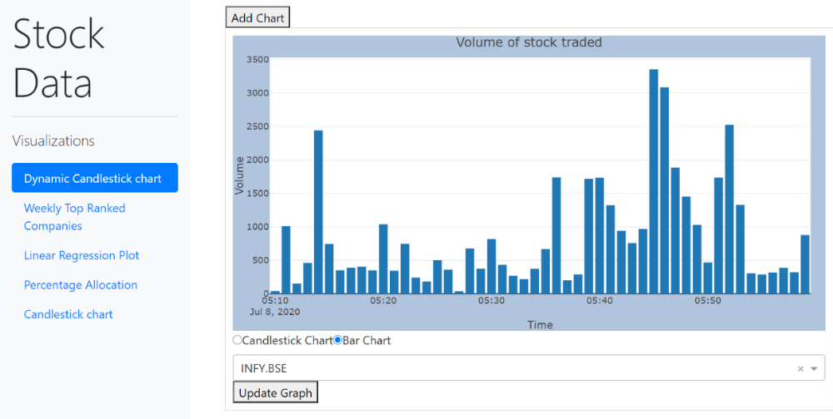

Intraday Stock Data for INFY.BSE (1min): Volume of stock traded per minute

Candlestick is a visual representation of price movements for a given period of time and formed by the ohlc prices (open, high, low, and close prices). Red candlestick will be drawn if the opening price is above the closing price. On the other hand, the green candlestick will be drawn if the opening price is below the closing price.
Dash application creates interactive and dynamic graphs. To add on top of it filter functionality is given for this graph. Users can choose any company symbol from Dropdown; data will be filtered based on symbol and the corresponding chart will be plotted dynamically. Candlestick (Intraday stock data (1min)) and bar charts (volume of stock traded) are been created for the last 50 records i.e. in this case 50 candles (50 bars of volume) will be created for 1 minute each. Moving average with windows 5 and 8 (MA-5, MA-8) is calculated and plotted with a candlestick chart. Radio button used to switch between graphs, and update graph button on click event will update the graph with new records if any new record stored into the mongo dB (live updates the graph on click event). Add chart button will add the exact same set of HTML components below with same functionality. It will add new children to the container. To create such a dynamic plot, dash new pattern- matching call-back functionality is been used. plotly.graph_objs.Scatter(), plotly.graph_objs.Candlestick() and plotly.graph_objs.Bar() function are used to plot intraday stock data graphs. Code for creating this graph are really big cannot be shared in report.
To gain insights about buying and selling of stocks we implement the concept of slow-moving average and fast-moving average. Whenever the fast-moving average line cuts the slow-moving average line from below it is an indication to buy stocks and whenever the fast moving average line cuts the slow moving average from above it is a signal to sell the stock.
For fast moving average we have considered 5 minutes as the period and for slow moving average we have considered 8 minutes as the period.
That means the fast moving average would be calculated on 5 candles of 1 minute data and slow moving average would be calculated on 8 candles of 1 minute data. We can consider different periods for fast and slow moving average. The fast and slow moving average is calculated from Fibonacci series.

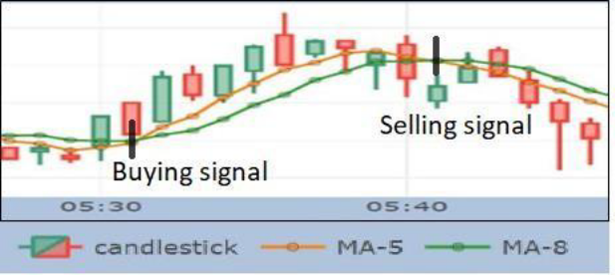

Pictorial representation of buying and selling signal based on the fast and slow moving average for Intraday trading. Orange line represents the fast moving average of 5 minutes period and green line represents the slow moving average of 8 minutes period.

Linear Regression Plot: Scatter plot with Regression line:
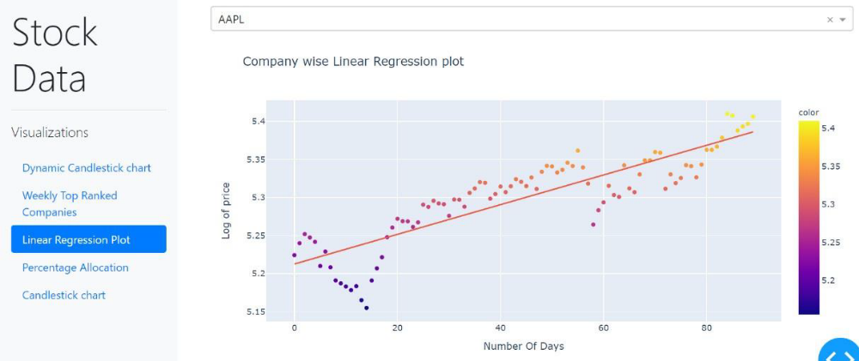

Linear Regression for AAPL company: Scatter plot with regression line

Concepts of regression algorithm are been used. From the scatter plot with regression line for the AAPL company, it seems that overall trend is in an upward direction. One can clearly see that better the regression line fits the data, the slope is increasing in a positive direction and R^2 is 0.75 which good figure says correctness of predicted values, so we can say that the higher will be the rank.

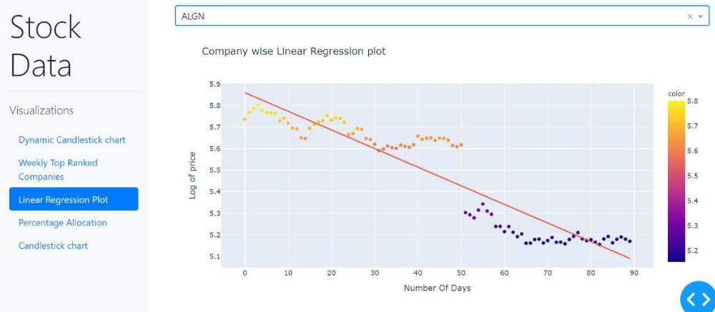

Linear Regression for ALGN company: Scatter plot with regression line

From the graph for the ALGN company, the overall trend is in a downward direction. One can clearly see that better the regression line fits the data but the slope is decreasing. So one can say that close price is been drastically dropping for this company stock and can see more decline in future and R^2 is 0.86 which says about the significance of predicted values of the closing price.
px.scatter(x=x, y=log_y, trendline="ols", title='Company wise Linear Regression plot', color=log_y,
height=500, labels={'y': 'Log of price', 'x': 'Number Of Days'})

Top 20 Ranked Companies:
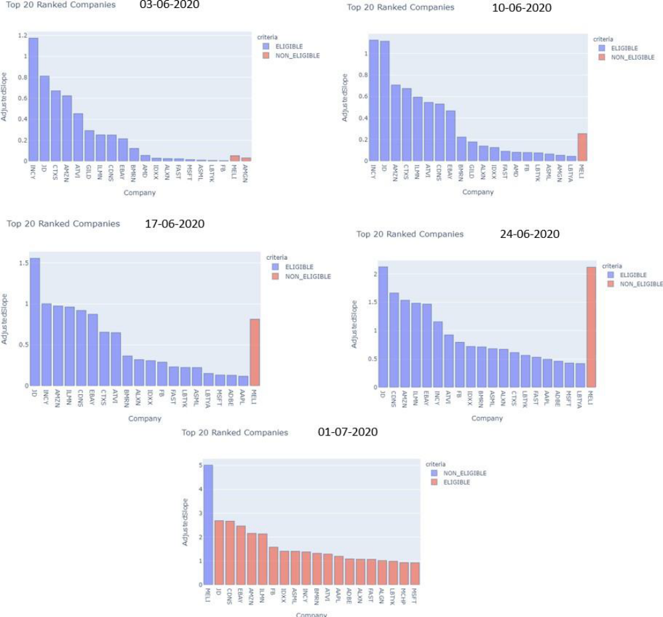

Top 20 companies of the weekly

Concepts of regression algorithm are been discuss in algorithm section 5. Bar Graph shows the top 20 companies ranked on basis of adjusted slope and ATR on weekly basis. From graph, it been clearly seen the position of companies in top 20 rank. JD, CDNS are consistently have position in top 5 companies. MELI shows some drastic changes in its position along the period of 5 weeks. MELI have position in top list but not eligible to consider in trading as its price experience fluctuations is more than 15% or its price comes below SMA (of that specific company). JD and CDNS are top most ranked companies. This graph will help to see which companies have good ranked so user can think about investing (buy or sell stocks) in those companies’ stocks.
Plotly.express.bar() is use to plot top 20 companies –
px.bar(df_rank.head(20), y=df_rank['AdjustedSlope'].head(20),
x=df_rank['Company'].head(20),
hover_data=['CurrentPrice', 'ATR'],
labels={'color': 'criteria', 'y': 'AdjustedSlope', 'x': 'Company'},

height=500,

color=df_rank['Eligibility'].head(20) , title='Top 20 Ranked Companies')\

.update_traces(dict(marker_line_width=1, marker_line_color="rgb(8,48,107)" , opacity=0.6)))

Company stocks percentage allocation - Pie Chart:
Users can see a percentage allocation of stocks by the company. Percentage allocation is calculated by percent_allocation = (stocksize * currentprice)/account_value

where stocksize is the number of stocks one is buying multiplied by current price of a stock than divided by the individual’s account balance.
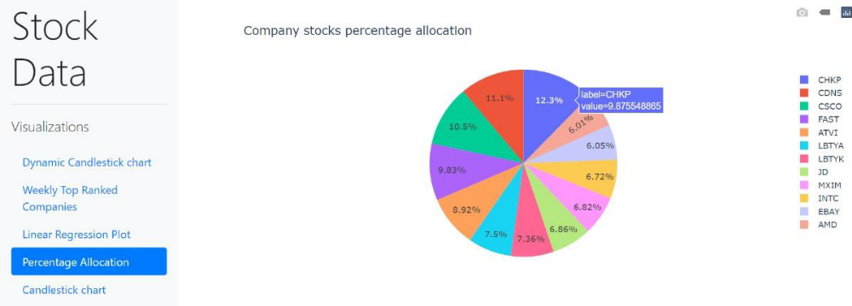
Percentage Allocation for top 12 companies
In this case, we have plotted the top 12 companies and their percentage allocation using a pie chart. As seen in graph CHKP is the company, which has the highest percentage allocation of 12.3% with a value of 9.87 (adjusted slope). This means that depend on current account balance, one should invest 11.4 % of money from account into CHKP company stocks to make profit. Same applicable for others.
plotly.express.pie() method is used to plot the pie chart –
px.pie(df_pie, values=df_pie['PercentageAllocation'].head(12),
names=df_pie['Company'].head(12), title='Company stocks percentage allocation'))

